Problem 1



Problem 2

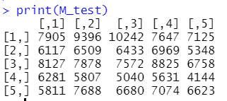

Problem 3

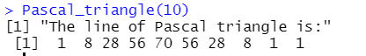

Problem 4

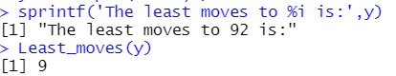

Problem 5

This problem is not finished, but I have a thought:

To randomly plug in front of each number with “+”, “-”or””(nothing) can get every possible equation to get the aim.

Problem 6

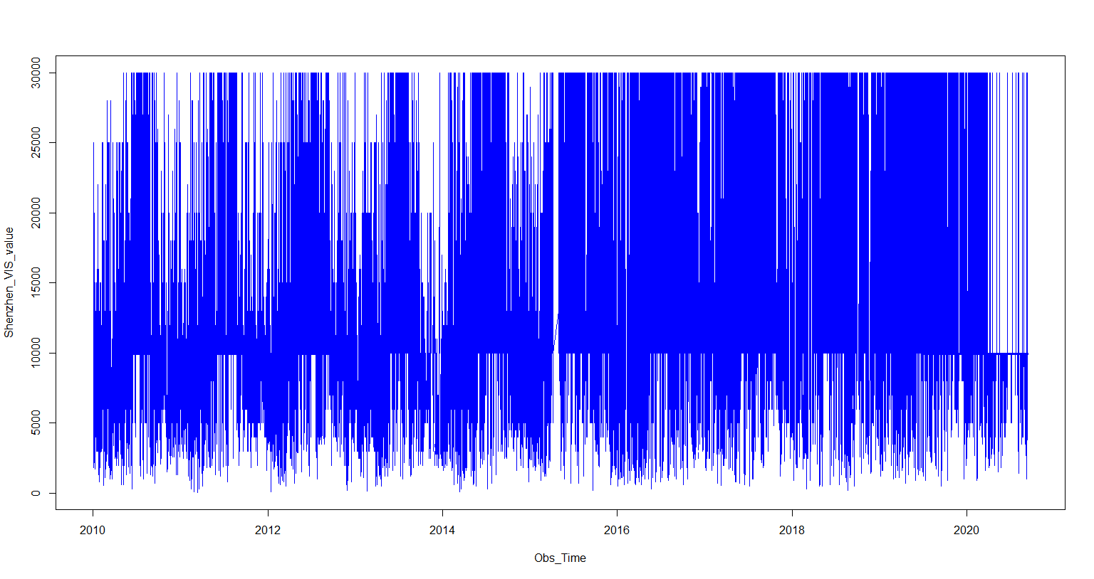

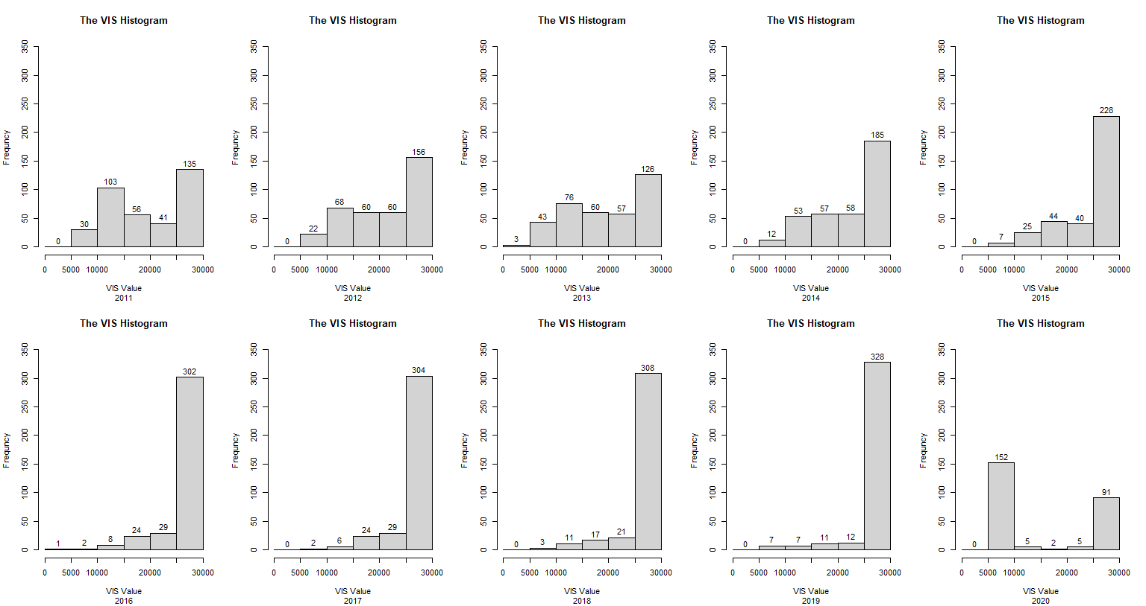

Problem 7

